Who Should Do This Lab: All Participants

### Oracle SQL Developer

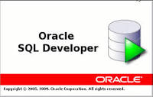Oracle SQL Developer is a free, integrated development environment that simplifies the development and management of Oracle Database in both traditional and Cloud deployments. SQL Developer offers a worksheet for running queries and scripts, a DBA console for managing the database, a reports interface, a complete data modelling solution, and a migration platform for moving your 3rd party databases to Oracle.

The labs make extensive use of SQL Developer, so you need to install it on your computer as a pre-requisite.

### Installing Oracle SQL Developer

You can download SQL Developer Version 18.4 (or the latest version if higher than 18.4) from OTN (make sure you download the correct version for your type of computer and operating system, you can also search for Oracle SQL Developer download if you have problems with the link):

<https://www.oracle.com/technetwork/developer-tools/sql-developer/downloads/index.html>

Make sure to accept the License Agreement or the download option won’t appear. Then select your appropriate architecture and download.

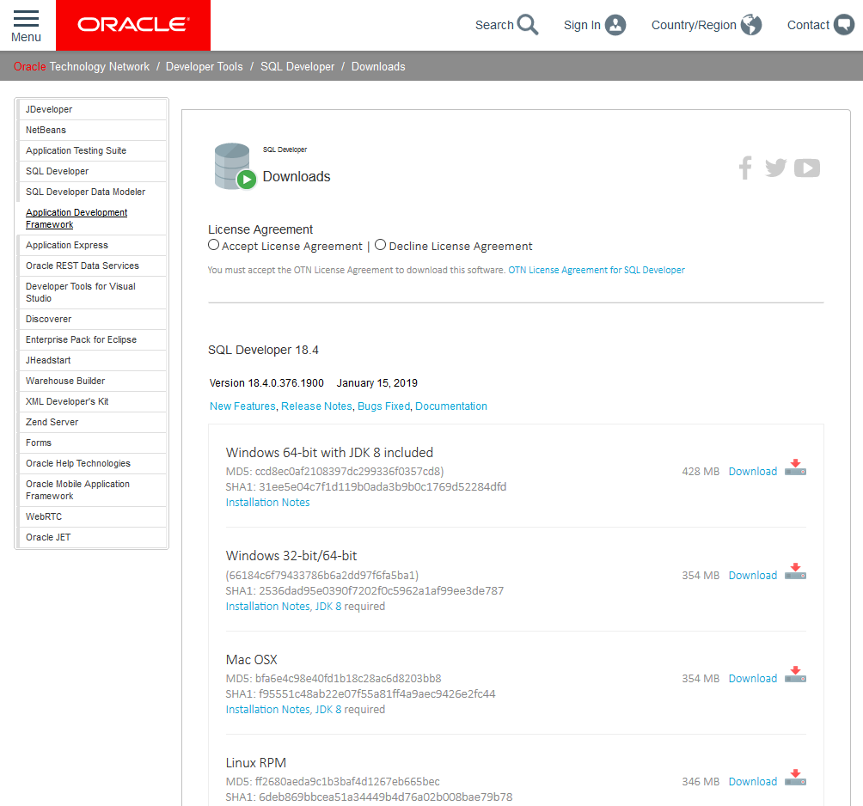

#### PLEASE NOTE Mac OSX and Linux:

Java SE Development Kit 8u201 is required and can be installed from here (please read SQL Developer installation notes for Max OSX and Linux RPM:

<http://www.oracle.com/technetwork/java/javase/downloads/jdk8-downloads-2133151.html>